

Draw It or Lose It

CS 230 Project Software Design
Version 1.0

Table of Contents

CS 230 Project Software Design Template 1
Table of Contents 2
Document Revision History 2
Executive Summary 3
Requirements 3
Design Constraints 3
System Architecture View 3
Domain Model 3
Evaluation 4
Recommendations 5

Document Revision History

Version | Date | Author | Comments
1.0 | 05/22/26 | Emily Soriano | First version of the software design document

Executive Summary

The Gaming Room would like to expand their game, Draw It or Lose It, from an Android-only app into a web-based game that can work across multiple platforms and devices. Since the game will need to support multiple users, teams, and players at once, the software must be designed in a way that keeps everything organized and efficient. It is also important that Game and Team names remain unique so users do not accidentally create duplicates, and that only one game service exists in memory at a time to avoid inconsistencies.

To support these needs, a Java-based application using object-oriented programming and software design patterns was created. The singleton pattern is used to make sure there is only one GameService object managing game data, while the iterator pattern helps check for duplicate game, team, and player names before creating them. An Entity class is also used to store shared information, such as names and IDs, which helps reduce repeated code and makes the application easier to manage and expand in the future.

Requirements

The Gaming Room wants Draw It or Lose It to move from an Android-only application to a web-based game that can support multiple platforms. The application must allow one or more teams to participate in a game, and each team must include multiple players. Game and team names need to stay unique so users can easily tell whether a name is already being used. The system must also make sure only one instance of the game service exists in memory at a time while assigning unique IDs to games, teams, and players. Overall, the application should be organized, scalable, and easy to maintain as the game grows.

Design Constraints

Developing Draw It or Lose It as a web-based distributed application comes with a few important design constraints. Since the game needs to work across multiple platforms and devices, the software must be flexible and consistent across different environments. Because users may be connecting from different devices and locations, network reliability and communication between systems also need to be considered.

Another important requirement is making sure Game, Team, and Player names stay unique. To handle this, iterator logic was used to search through existing names before creating new objects. The system also needs to make sure there is only one GameService object in memory at a time, which is why the singleton pattern was implemented. This helps keep the game data consistent and prevents duplicate services from being created.

To make the software easier to maintain and expand later, inheritance was used through a shared Entity class. Since Game, Team, and Player all need ID and a name, storing those shared attributes in one place helps reduce repeated code and keeps the application more organized!

System Architecture View

Please note: There is nothing required here for these projects, but this section serves as a reminder that describing the system and subsystem architecture present in the application, including physical components or tiers, may be required for other projects. A logical topology of the communication and storage aspects is also necessary to understand the overall architecture and should be provided.

Domain Model

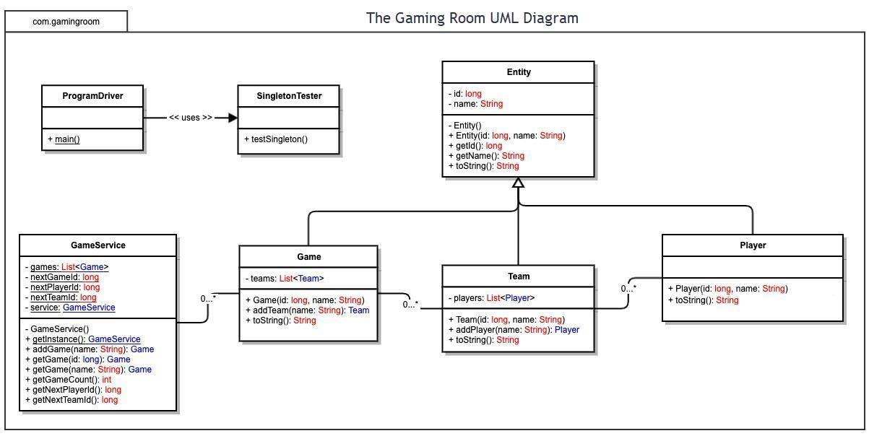

The domain model for Draw It or Lose It shows how the main classes in the application relate to one another. The GameService class acts as the main manager for the application and stores multiple Game objects. Each Game can contain multiple Team objects, and each Team can contain multiple Player objects. This structure reflects how the game works in practice, since games contain teams and teams contain players.

The Entity class acts as a parent class that stores shared attributes such as an ID and name. The Game, Team, and Player classes inherit from Entity, which demonstrates the object-oriented principle of inheritance. Encapsulation is also shown by using methods to retrieve information rather than directly accessing data. In addition, the singleton pattern is used in GameService to make sure only one instance exists in memory, while iterator logic is used to search collections and prevent duplicate names.

These object-oriented principles help keep the software organized, reusable, and easier to maintain!

Evaluation

Using your experience to evaluate the characteristics, advantages, and weaknesses of each operating platform (Linux, Mac, and Windows) as well as mobile devices, consider the requirements outlined below and articulate your findings for each. As you complete the table, keep in mind your client’s requirements and look at the situation holistically, as it all has to work together.

In each cell, remove the bracketed prompt and write your own paragraph response covering the indicated information.

Development Requirements | Mac | Linux | Windows | Mobile Devices
Server Side | Mac can host a web-based application and offers a stable, Unix-based environment that supports development tools. However, it is more expensive and less commonly used for large-scale hosting, making it better suited for development than server hosting. In addition, hosting Mac would require Apple hardware, which can increase overall deployment costs compared to Linux-based servers. | Linux is a strong choice for hosting because it is stable, secure, scalable, and widely used for web servers. Since it is open source, it is also cost-effective, although it may require more technical experience to manage. Because Linux is open source, there are generally no operating system licensing fees, making it an attractive option for a growing web-based game. | Windows can host web-based applications and works well with many business tools. However, licensing costs and higher system resource use may make it less efficient than Linux for a distributed gaming application. Windows Server can support large web applications, but licensing costs may increase as the application grows and requires additional resources. | Mobile devices are not ideal for hosting web-based software because of limited storage, processing power, and network reliability. They work better as devices used to access the application rather than host it. Because of these limitations, mobile devices would be used as clients connecting to a server rather than acting as the hosting platform.
Client Side | Supporting Mac users would require browser testing and some familiarity with macOS, but web-based access helps reduce development complexity. Costs and development time would remain manageable. Developers would also need to test across multiple browsers, which may increase development time, but helps ensure a consistent user experience! | Linux support may require extra browser and compatibility testing across different distributions. Since the game is web-based, development is easier because users access the application through browsers. Additional expertise may be needed to test across different Linux distributions and browser configurations. | Windows support is important because it is widely used. Testing across browsers and devices may take extra time, but compatibility is generally straightforward for web applications. Because Windows is widely used, ensuring compatibility across major browsers such as Chrome, Edge, and Firefox would be an important part of development. | Supporting mobile devices requires additional testing for screen sizes, responsiveness, and touch controls. Although this increases development time, mobile access is important for user convenience. Supporting both Android and iOS may increase development costs and testing time, but it helps make the game accessible to a larger audience.
Development Tools | Mac supports Java and web technologies such as HTML, CSS, and JavaScript. IDEs like VS Code, IntelliJ IDEA, and Eclipse can be used for development and testing. Most of these tools are available at little or no cost, although Apple hardware may increase development expenses. | Linux supports Java, web technologies, and development tools such as VS Code, Eclipse, and IntelliJ IDEA. It is commonly used for server development because of its flexibility and performance. Many Linux development tools are open source, which helps reduce software licensing costs for the development team. | Windows supports Java Development and tools like VS Code, Eclipse, and IntelliJ IDEA. It is widely used and provides many options for testing and development. These tools allow developers to work within a familiar environment, reducing training time for teams already using Windows. | Mobile development may involve Java or Kotlin for Android and Swift for IOS, along with responsive web technologies. Testing tools are important to ensure compatibility across different devices. Mobile development may require additional testing resources and specialized knowledge of Android and iOS platforms.

Recommendations

Analyze the characteristics of and techniques specific to various system architectures and make a recommendation to The Gaming Room. Specifically, address the following:

- Operating Platform:

I recommend using Linux as the main server platform for Draw It or Lose It. Even though many users may access the game from Windows, Mac, or mobile devices, Linux is a strong choice for hosting a web-based application because it is stable, secure, scalable, and widely used for servers. Since Linux is open source, it can also help reduce costs while still allowing users on different operating systems to connect through a web browser. Linux is also commonly used in cloud environments, which would make it easier to expand the application if the number of users grows in the future.

- Operating Systems Architectures:

Linux uses an architecture that can efficiently manage multiple users and processes at the same time, which is important for a multiplayer game running in a distributed environment. Because Draw It or Lose It will support players across different platforms, the server needs to handle requests from many devices at once while remaining reliable and responsive. This allows the server to support many active users at once while maintaining performance and reliability as the game grows.

- Storage Management:

For storage management, I would recommend using a database system such as MySQL or PostgreSQL with the Linux server. This would help store game information, teams, players, and user data in an organized way. Using a database would also make it easier to update, search, and manage information as the game grows. Since Draw It or Lose It uses a large collection of images, storing image information in an organized way will help the application find and load resources more efficiently.

- Memory Management:

Linux uses memory management techniques such as virtual memory and process management to help software run efficiently. This would help Draw It or Lose It support multiple games and users without using resources inefficiently. The use of the singleton pattern in the software design also helps by making sure only one GameService instance is running in memory. Linux can also use caching and virtual memory to improve performance. This helps images load more quickly during gameplay without needing to keep every image in memory at the same time.

- Distributed Systems and Networks:

To allow communication between different devices and operating systems, Draw It or Lose It should use a client-server model. The Linux server would host the application while users connect through web browsers on Windows, Mac, Linux, or mobile devices. Since this depends on internet connectivity, the system should be designed to handle slow connections or outages as smoothly as possible. Another advantage of a distributed system is that the server can continue managing game information even if the player’s connection is interrupted. This can definitely help improve reliability when network issues occur.

- Security:

Security is important because the application may store player and game information! To protect users, the system should use HTTPS encryption, secure login methods, and protected database access. Linux also provides strong security features such as permissions, firewall tools, and regular updates to help keep user data safe across different platforms. Additional security measures such as encrypted passwords, user permissions, and regular software updates can help reduce the risk of unauthorized access and protect player information.

